WALK IN CHAMBER-HAMCO63/64 SERIES
When your testing requires walk-in rooms, choose
“HAMCO” Controlled Temperature Solution. Our test room feature automated process control, energy efficiency, and a vast range of features equipment that reliably produce required conditions, structural integrity that keeps the room working properly through year of demanding test cycles, and measuring/monitoring equipment that precisely records all test data. Hamco make GMP walk in stability test chambers are especially built to pass FDA and ICH Q1A compliance standards and have a reputation for reliability, quality and performance.

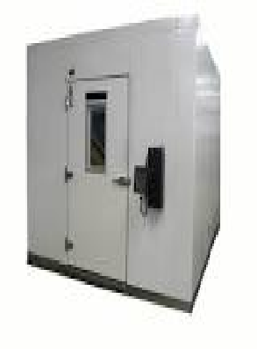

Capacity :5400,6400,8000,9600,12000,15000,18000,30000,50000,80000 Litres
BACTERIOLOGICAL INCUBATOR – HAMCO 41 SERIES
“HAMCO” make Bacteriological Incubator are specifically designed for Research laboratories , Engineering Lab, Pharmaceutical Lab, Cosmetic Industry , Chemical Lab, Clinical Lab ,Microbiological Determination , Pharmaceutical Stability Assays, Food Processing QC. Hamco make Bacteriological Incubator are specially designed for Research laboratories , Engineering
Lab, Pharmaceutical Lab, Cosmetic Industry ,ChamicalLab , Clinical Lab Microbiological Determination , Pharmaceutical Stability Assays, Food Processing, QC.HAMCO Make GMP Lab Incubator is especially built to Pass FDA and ICH Q1A compliance standards and have a reputation for reliability, quality and performance. Exceed FDA/ICH guidelines for long term, intermediate and accelerated stability studies.
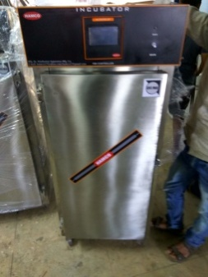

Capacity (Litres): 20,45,90,,120,200,324,450,600,800,1000,1500,2000 litres
STABILITY CHAMBERS – HAMCO 44 SERIES
Whether your testing is for R&D, Clinical
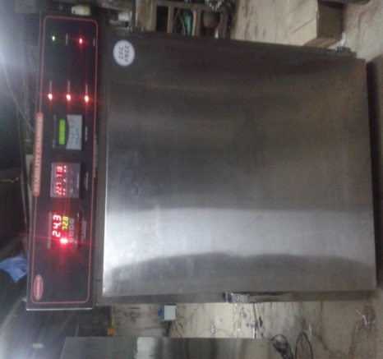
Trials or ongoing stability, HAMCO Stability chamber provide a stable temperature & humidity condition environment for warranty- free operations with a control system that is easy to operate. Hamco make Stability Chamber are designed as per ICH guidelines and are manufactured to comply requirements in the industries. Stability Testing is an integral part of formulation development .It considered proposals to be made for the shelf life of drug substance and product and recommended storage condition .HAMCO Make GMP stability test chambers are especially built to Pass FDA and ICH Q1A compliance standards and have a reputation for reliability, quality and performance. Exceed FDA/ICH guidelines for long term , intermediate and accelerated stability studies

Capacity (Litres): 90,120,200,324,450,600,800,1000,1500,2000 Litres
PHOTO STABILITY CHAMBERS – HAMCO 43 SERIES
Whether your testing is for R&D, Clinical
Trials or ongoing photo stability, HAMCO photo Stability chamber provide a stable temperature & humidity condition & light intensity environment for warranty- free operations with a control system that is easy to operate. Hamco make Photo Stability Chamber are designed as per ICH guidelines and are manufactured to comply requirements in the industries.Photo Stability Testing is an integral part of formulation development .It considered proposals to be made for the shelf life of drug substance and product and recommended storage condition .HAMCO Make GMP stability test chambers are especially built to Pass FDA and ICH Q1A compliance standards and have a reputation for reliability, quality and performance. Exceed FDA/ICH guidelines for long term , intermediate and accelerated stability studies. This chamber has the capability to provide fluorescent light intensities from 1,000 to 10,000 Lux hour. Samples stored at 10,000 Lux can satisfy the ICH guidelines for light exposure in as little as five days. The UV study is done simultaneously. Separate switches are provided for incandescent & UV light sources.

BOD INCUBATOR – HAMCO 42 SERIES
“Hamco” make BOD incubator are manufactured to comply requirement of Industries . Specifically designed for long term and stable continuous operation ideal for pharmaceutical , Bio technology and Research institution for storage and incubation studies.HAMCO Make GMP BOD Incubator is especially built to Pass FDA and ICH Q1A compliance standards and have a reputation for reliability, quality and performance. Exceed FDA/ICH guidelines for long term, intermediate and accelerated stability studies.
Capacity (Litres) :100,170,200,285,325,400,600,800,1000,1500,2000.
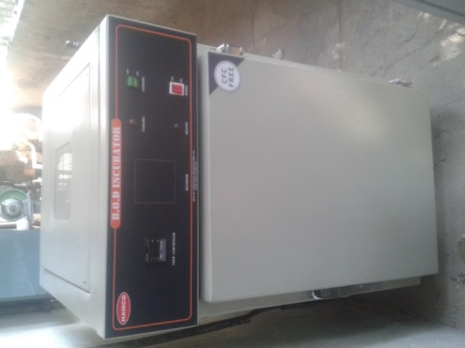
DEEP FREEZER (-20⁰_{C/ -40}⁰_{C/ -60}⁰_{C/ -80}⁰_{C ) – HAMCO 47 SERIES}
“Hamco” make Deep Freezer are designedto provide an ideal freezing environment for advanced medical and industrial application and also suitable for Research , Blood Bank Biological Use includes preservation of plasma, blood components , vaccines , etc. These Deep Freezer units are available in horizontal or vertical versions
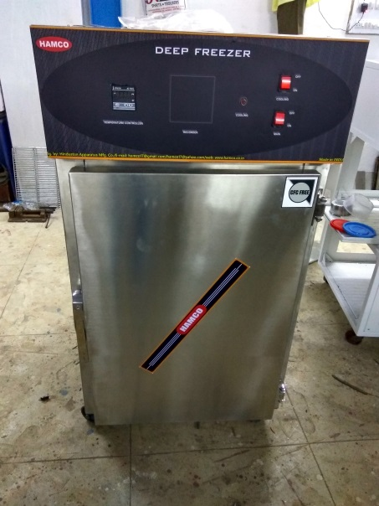
Capacity ( Litres) : 90, 120, 200, 324, 450.

DUAL CHAMBER
“Hamco” make Dual Chamber are designed to provide space saving solution .Ideal for lab with limited space wherein combination of different equipment is provided in single vertical model.
Available in any combinations of : - Lab Refrigerator, BOD Incubator, Bachteriological Incubator , Deep Freezer, Stability Chamber ,Oven Etc
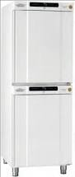

LAB REFRIGERATOR- HAMCO45 SERIES
“HAMCO” Make Lab Refrigerators are stable and reliable with refrigerated environment for exact laboratory requirement . Lab refrigerators are for maintaining storage conditions of a product, exposure to low temperature requirements are on the lower side . Ideal temperature environment for clinical research, pharmaceutical and industrial use.
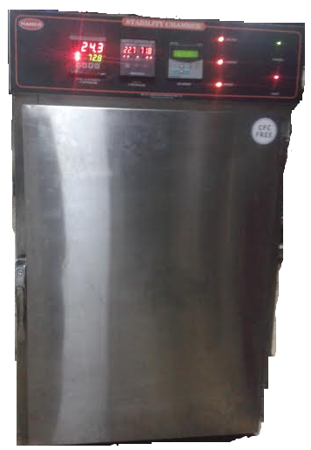
Capacity ( Litres) : 100,170,200,285,325,400,600,800,1000,1500,2000.
CRYOSTATE BATH (₀⁰_{C/ -20}⁰_{C/ -40}⁰_{C/ -60}⁰_{C/ -80}⁰_{C}) – HAMCO40 SERIES
“ Hamco” cryo baths are designed for research work at desired temperature with high accuracy . The temperature is controlled by microcontroller base PID controller with an accuracy of 1 deg C. The unit is provided with a circulating pump to ensure uniform temperature.
Hamcocryo bath offer a combination of contemporary cabinet design, advanced micro controller and a range of accessories to suit your specific laboratory or process application. High – strength cabinet construction with stainless steel interior tanks withstand the most critical applications in demanding laboratory environments. The unit is mounted on castor wheels for ease of mobility.
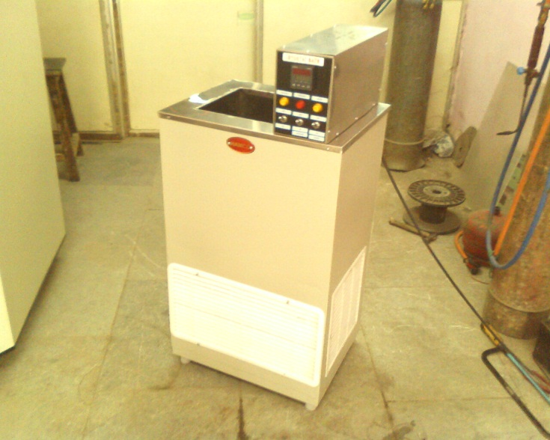
Capacity litres:15 LTR
GLASS DOOR LAB REFRIGERATOR
“HAMCO” make lab refrigerator are stable and reliable with refrigerated environment for exact laboratory requirements. Laboratory refrigerators are for maintaining storage conditions of aproduct, exposure to low temperature appplications , where the temperature requirements are on the lower side. Ideal temperature environment for clinical research, pharmaceutical and industrial use.

BLOOD BANK REFRIGERATOR : HAMCO 46 SERIES
“HAMCO” make Blood bank refrigerator are stable and reliable with refrigerated environment for exact blood bank storage requirements. Blood bank refrigerators are for maintaining storage conditions of blood bag, exposure to low temperature appplications , where the temperature requirements are on the lower side. Ideal temperature environment for blood bank storage.

HEATING & COOLING CHAMBER (FREEZE THAW CHAMBER) : HAMCO 39 SERIES.
“HAMCO” ‘HEATING AND COOLING CHAMBER WITH HUMIDITY CONTROL’ is designed primarily to meet the requirements for tests of thermal shock and various industrial applications. These chambers are designed to meet the testing challenge of vary industrial application.
HAMCO Make GMP ‘HEATING AND COOLING CHAMBER WITH HUMIDITY CONTROL’ is especially built to Pass FDA and ICH Q1A compliance standards and have a reputation for reliability, quality and performance. Exceed FDA/ICH guidelines for long term, intermediate and accelerated stability studies.
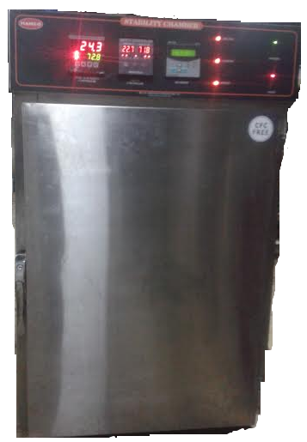

Vacuum or Inert Tube Furnace :- ( 1000 /1200/1400 deg C)-HAMCO15 SERIES
“HAMCO” make vacuum or inert tube furnace are widely used in the laboratory and analytical laboratories for research and analysis. This tube furnace having the facility to do vacuum and inert atmosphere.This furnaces also have the programmable control facility with data recording facility.
Size : 50mm , 75mm , 100mm Id. Heating zone 300mm, 450mm.
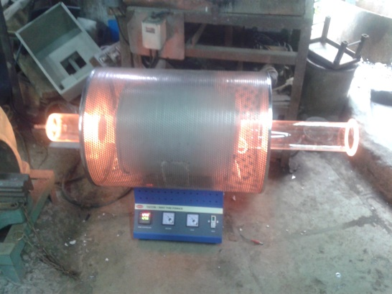

LABORATORY DRYING OVEN (Forced Air Draft )- HAMCO 102 SERIES
“ Hamco” make Lab Drying HAMCO101 series ovens with Forced Air Draft provided by means of Blower fitted the Bottom of the Oven . ( There is no re- circulation of air). These ovens are suitable for drying a range of items such as glassware and components and any general purpose warming applications. Ovens are made of Double walled construction.
Capacity ( Litres) : 27,43, 91 , 122, 216, 324,400,600,800,1000
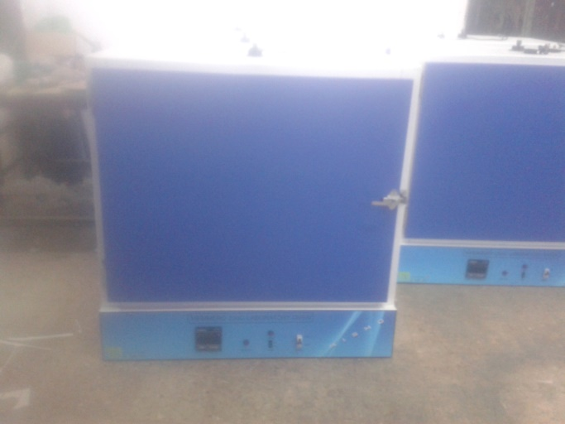

LABORATORY PRECISION OVEN (Forced Air Circulation) -HAMCO 101 SERIES
“ Hamco” make Lab precision Oven are with forced air circulation provided by means of motorized blower fitted on the oven for re- circulation of air ensures a homogenous hot air mixture and an exact temperature profile . Ovens are made of Triple walled construction . The unit is insulated with 3” high grade glass wool . Single door fitted on heavy hinges . The unit is provided with user friendly adjustable stainless steel rod mesh trays.
Capacity (Litres) : 43, 91, 122,216 ,324,400,800,1000.
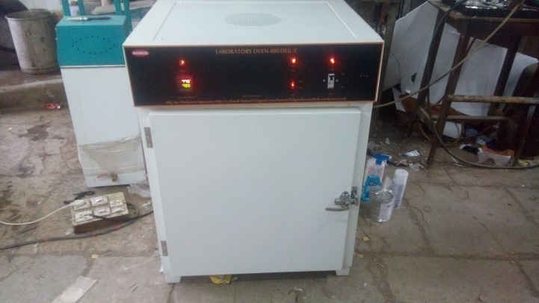
LABORATORY OVEN (Natural Convection )- HAMCO 105 SEIRIES
Hamco make Natural Convection ovens are ideal for sterilization, drying, and thermal storage tasks which do not require high drying rates or special time parameters. These ovens are made of double walled construction . The unit is insulated with 3” thick hogh grade glass wool insulation. Single door is fitted on heavy duty hinges. The unit is provided user friendly adjustable stainless steel rod trays.
Capacity ( Litres) : 27,43,91,122,216,324,400,600,800,1000
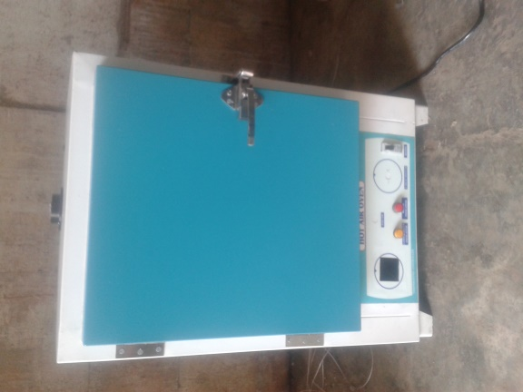
HIGH TEMPERATURE OVEN
“Hamco” high temperature ovens are manufactured in standard chamber sizes with maximum operation incorporates heavy duty hinges . Motorized blower with V-belt fitted on top side of chamber for re-circulation of air to maintain uniformity of temperature inside the chamber .Unique air- flow system which ensures quick recovery after door opening.
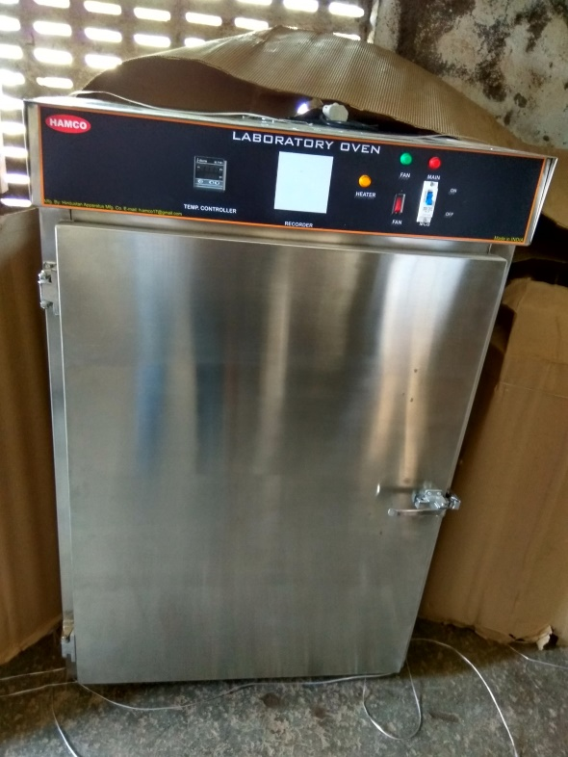

Capacity 43,91,122,216,324.
AUTOCLAVE (Vertical)
“Hamco” makeLaboretory Autoclave is suitable for pharma& Biotech industries , Food research & Quality assurance labs, Agriculture research , Health care & Diagnostic labs, University, etc.

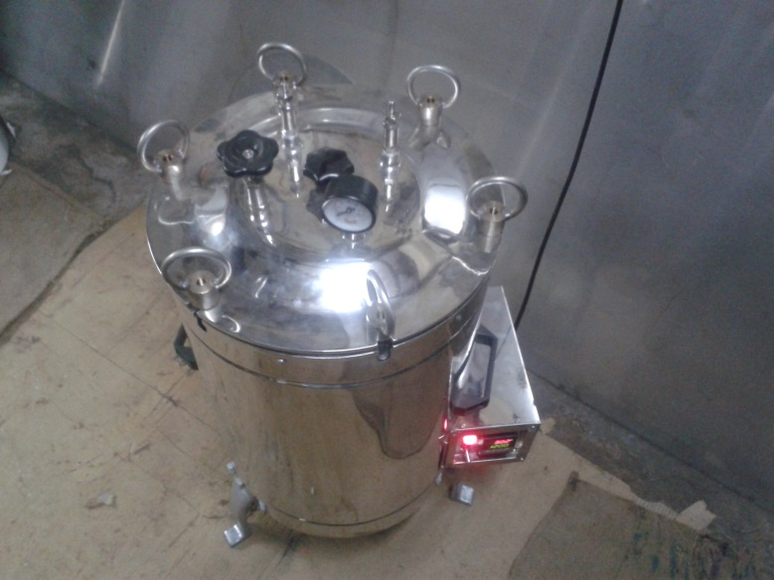
Capacity ( Litres) : 22,35,53,95,119,& 179 Litres
VACUUM OVEN – CIRCULAR & RECTANGULAR
“ Hamco” make vacuum ovens are designed & manufactured to comply requirements of industry . It is widely applicable for drying & sterilization in field of biochemistry , pharmacy, medicine, health , agriculture & scientific research and environment protection . It is designed specifically for drying of material which is thermo sensitive or decompounded and oxidative easily.

Temp.Range : 50⁰C to 200⁰C
Temp. Accuracy : ± 0.2⁰C
Supply : 230V, AC
Capacity (Litres ) : 11, 26,50 in circular Model ; 27,40,& 121 in Rectangular Models.
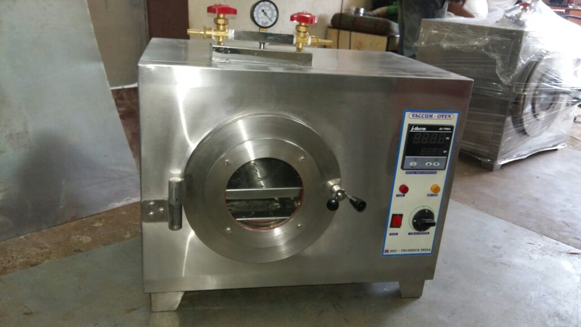

CONSTANT TEMPERATURE WATER BATH – HAMCO 23 SERIES.
These water baths are equipped with circulating pumps for uniform temperature & also for circulating fluids through external devices .
Temperature Range : 5 deg C above ambient to 90 deg C
Temperature accuracy : +/- 0.5 deg c
Capacity (LT ) : 15 Ltr
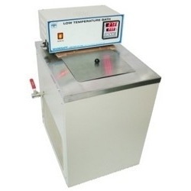
WATER BATH – HAMCO 24 SERIES
These water baths are double wall construction . supplied with drop on lid and rings.
Temperature Range : 5 deg C above ambient to 95 deg C.
Temperature accuracy : +/- 0.2 deg C.
Supply : 230v, single phase
HAMCO24A - With 4 holes of 7.5 cms dia & 1 hole of 12.5 cms dia
HAMCO 24B - With 6 holes of 7.5 cms dia
HAMCO24C - With 12 holes of 7.5 dia.
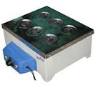

WATER BATH ( SEROLOGICAL ) – HAMCO 25 SERIES.
These water bath are widely used for bacteriological and Laboratory applications requiring incubation as well as generated tests.
Temperature Range : 5 deg C above ambient to 60 deg C
Temperature accuracy: +/- 0.5 deg C
Supply : 230 V, single phase
Capacity :- 8 ltr, 12 Ltr
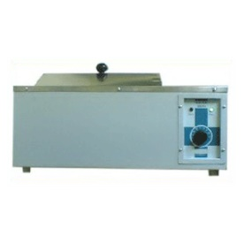

TRAY DRYER :- HAMCO 108 SERIES.
“Hemco” is a pioneer in tray dryers , with a wide range . Well appreciated for its durability and robust constructions ,these tray dryers are built to various specifications as per the client requirements . Final finish of the tray dryer , design and manufacture has aesthetic looks.
Maximum temperature attained inside the dryer is 150 deg C and will be indicated and controlled by a digital temperature indicator cum controller over full range of heating load.
Nos of Tray :4,5,7,12,24,48,96.
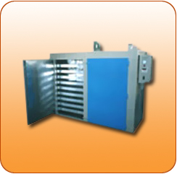
DRUM HEATERS :- HAMCO 59 MODEL
The verticle drum heater for drums in the vertical position The heating power is 12 kw . At 240C AC three phase.
Hamco drum heaters provide an easy , efficient, clean and economical way for the handling of viscous of low melting point soliditied materials in drums .such materials include asphalt , Bitumen , Fats, gelatin, glucose , grease, lubricating oils,paints, petroleum jelly, phenols, plastics, sodium tar, vanaspati, oil, varnishes & waxes etc.
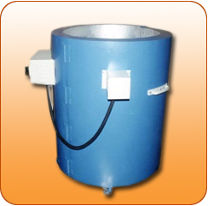
HIGH TEMPERATURE FURNACE :- HAMCO 60 SERIES
“Hamco” furnaces for high temperature applications with short heat up time &resistence to thermal shock. Designed with highest standards for quality for efficient high – temperature use with minimal maintenance .silicon carbide element with easy assembly . These furnaces are ideal for rapid cycling over extended periods .
Temperature range: 1500 Deg C max
(1450 deg C continuous)
Supply : Single phase / three phase
Capacity ( litres ) :: 2.3,4.25,6.75
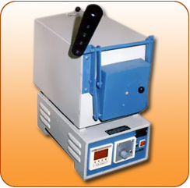
MUFFLE FURNACE :- HAMCO 60 SERIES
“Hamco” make muffle furnace are designed & manufactured to comply requirements for laboratory & Industrial applications . It is used for engineering tests of soils and aggregates , cement testing, ashing organic and inorganic samples , gravimetric analysis , ignition tests, etc. “ Hamco” make muffle furnace are constructed in horizontal / Rectangular model. Insulation is with high grade insulation material.
Temp Range :- 900, 1200,1400 deg c
Capacity ( litres ) : 2.3,4.25,6.75, 16,24,29.
WATER DISTILLER ;-
WATER STILL MANESTY TYPE – HAMCO 28 SERIES
Introduction :
“HAMCO” make water still are designed and fabricated to suit various I.S. standards to filter water from impurities, dissolved salts & odour in the field of Medical, Agricultural, Industrial, Research laboratories and Hospitals.
Features :
a) Pyrogen free distilled water.
b) Complete Stainless Steel.
c) Wall mounting.
Application :
General laboratory purpose water distillation plant
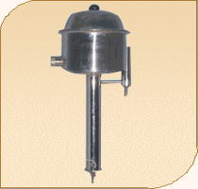
Capacity :- 2,4,6,8 lt/hr
WATER STILL BEARNSTEAD TYPE – HAMCO 27 SERIES
Introduction :
“HAMCO” make water still are designed and fabricated to suit various I.S. standards to filter water from impurities, dissolved salts & odour in the field of Medical, Agricultural, Industrial, Research laboratories and Hospitals.
Features :
a) Pyrogen free distilled water.
b) Complete Stainless Steel.
c) Floor mounting.
Application :
General laboratory purpose water distillation plant
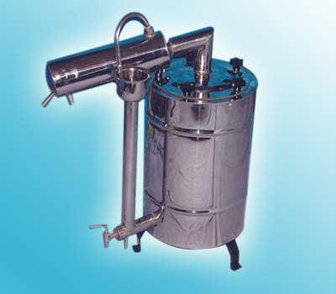
QUARTZ TWO STAGE DISTILLER :- HAMCO 26 SERIES.
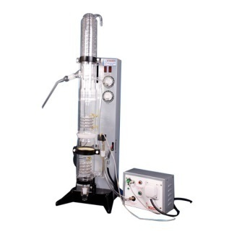
With the use of sophisticated technology, we have been able to manufacture Quartz Two Stage Distiller, a Basic Model. These are designed with precision to ensure these are efficient and are capable of proper distilling. Further to add to the performance of the distiller, we have fitted it with demountable boiler. For the convince of the clients, we have made provisions so that the first boiler can be dismantled from the 2nd Boiler and the condensing column.
Capacity :- 1,1.5,2,2.5,3,5 ltr/hr
WATER QUALITY TESTING
FLOCCULATOR ( JAR TEST APPARATUS ) – HAMCO 117 SERIES
HAMCO Digital Flocculator has been specially designed for use in water treatment plant as jar test apparatus to correctly estimate the dosing of alum and such other coagulants for treatment of water & sewage. It provides identical test condition for all samples. It is suitable for continuous run in any busy laboratory to determine sulphate concentration & for measuring suspended matter and colloids general.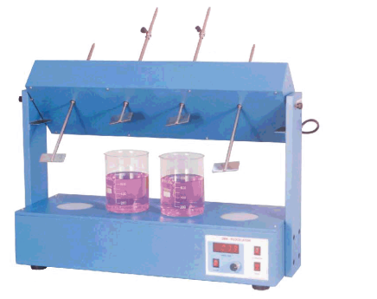
Capacity :- 2,4,6 Jar.
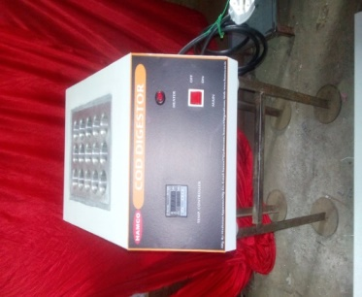
COD DIGESTOR :- HAMCO 109 SERIES
COD analysis requires digestion of samplers using pottassium dichromate and sulphuric acid,. HAMCO offers two models HAMCO109A which can accommodate 6 sample at a time and HAMCO109B which can accommodate 15 sample at a time . The digested sample is then titrated against FeS04 .
Capacity :- 6 sample, 15 sample.

